# Coding Challenge – 4 : Car Rental System (Meghanath P.)

## Questions

1. Update the daily rate for a Mercedes car to 68

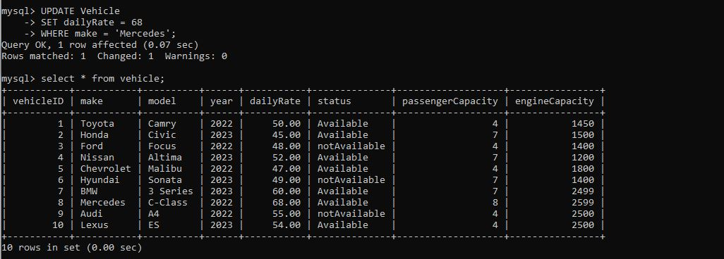

1. Delete a specific customer and all associated leases and payments.

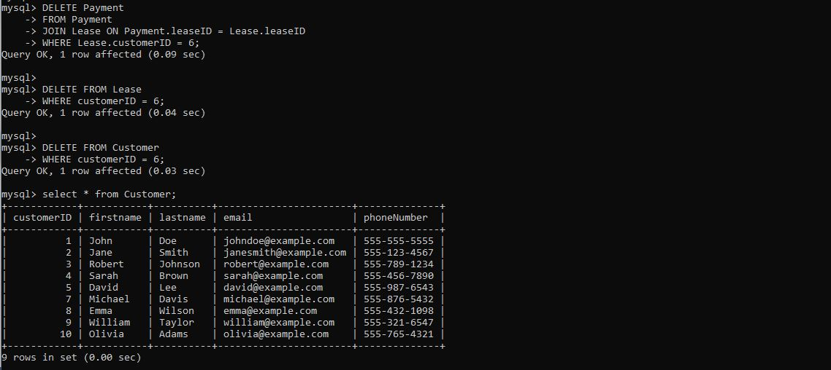

1. Rename the "paymentDate" column in the Payment table to "transactionDate".

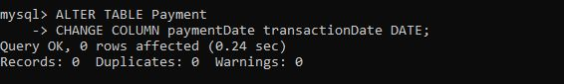

1. Find a specific customer by email.

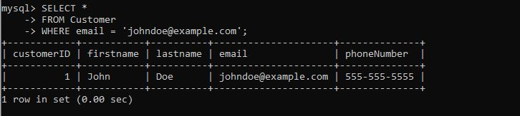

1. Get active leases for a specific customer.

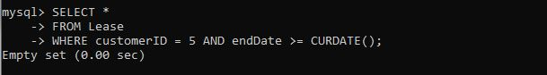

1. Find all payments made by a customer with a specific phone number.

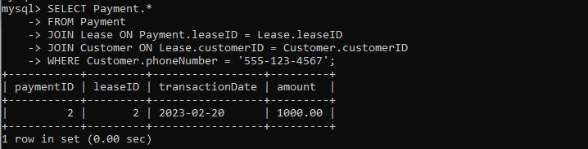

1. Calculate the average daily rate of all available cars.

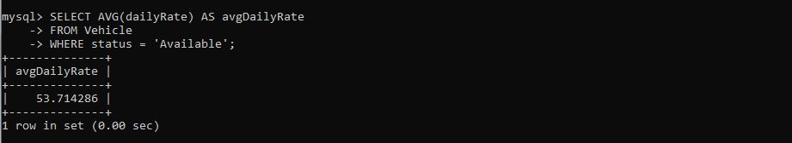

1. Find the car with the highest daily rate.

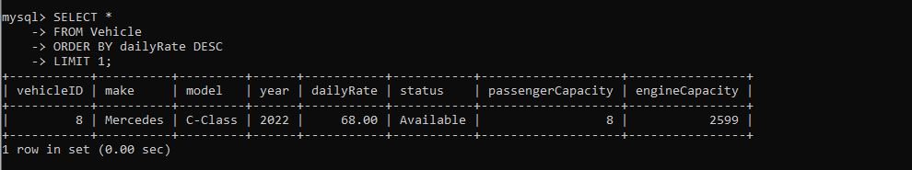

1. Retrieve all cars leased by a specific customer.

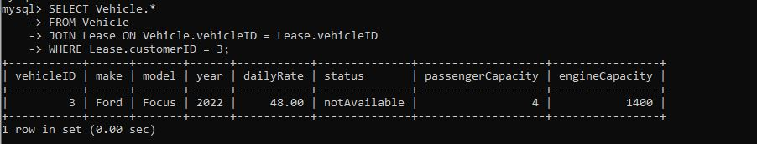

1. Find the details of the most recent lease.

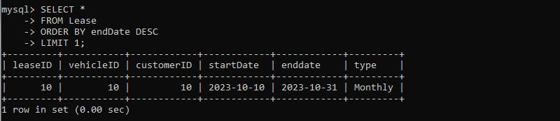

1. List all payments made in the year 2023.

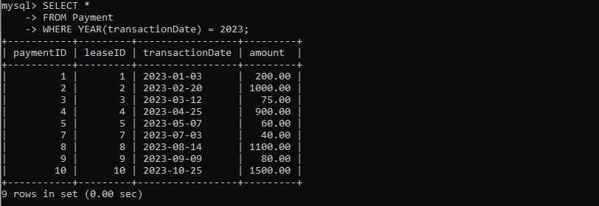

1. Retrieve customers who have not made any payments.

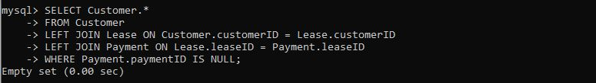

1. Retrieve Car Details and Their Total Payments.

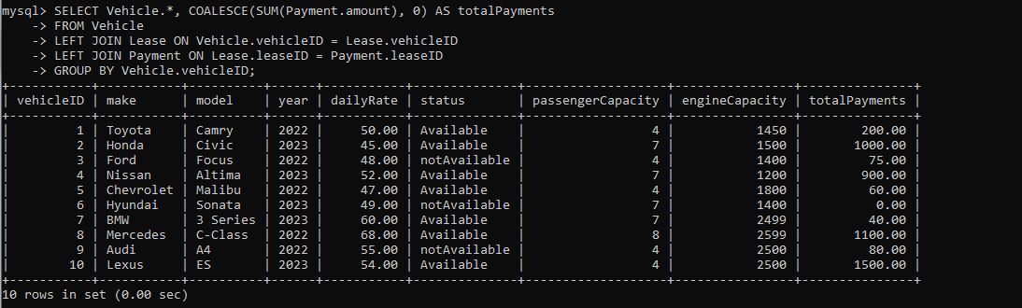

1. Calculate Total Payments for Each Customer.

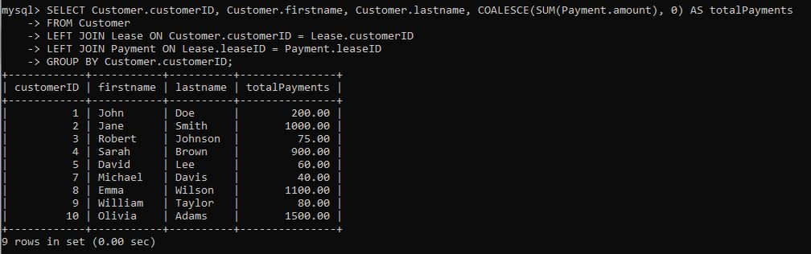

1. List Car Details for Each Lease.

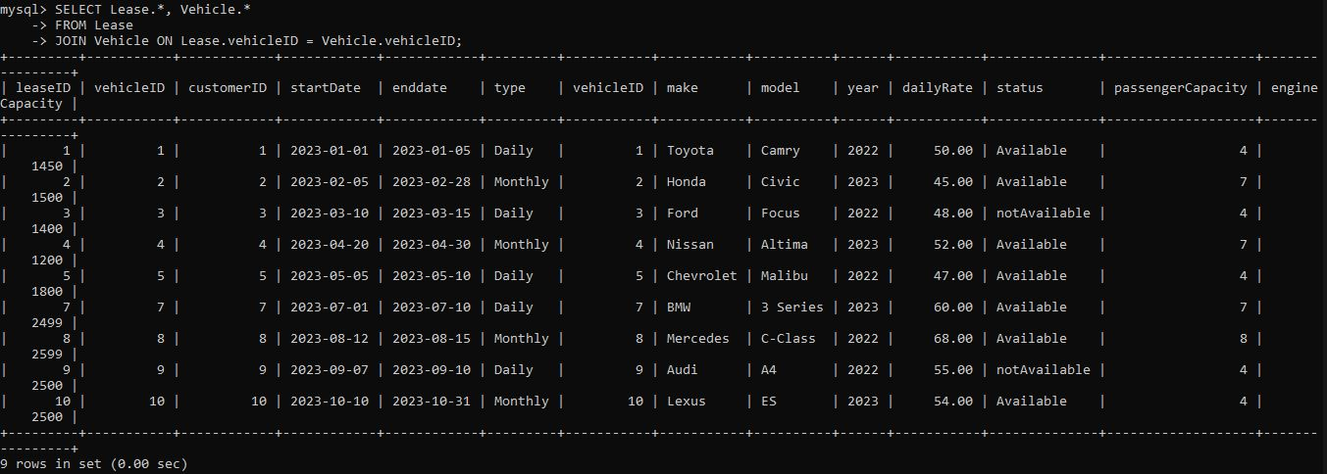

1. Retrieve Details of Active Leases with Customer and Car Information.

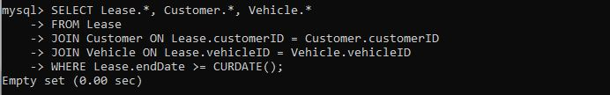

1. Find the Customer Who Has Spent the Most on Leases.

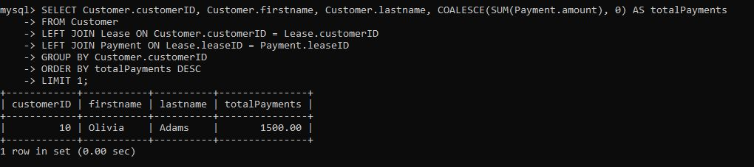

1. List All Cars with Their Current Lease Information

